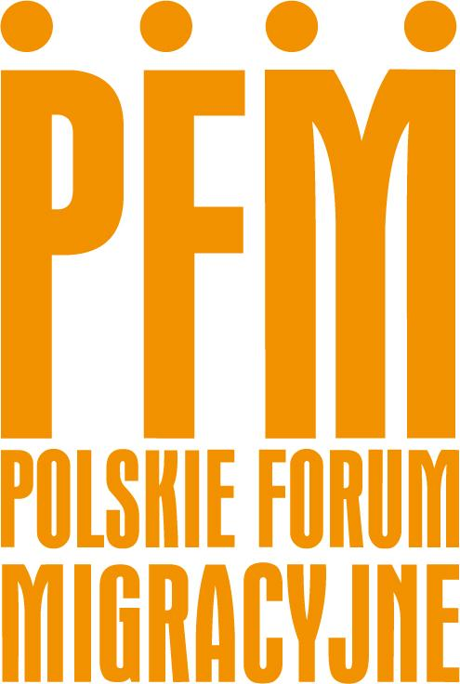

**Annex C:**

**Supplier Profile & registration Form**

This Registration Form enables the Danish Refugee Council (DRC) to gather information about your company. DRC can only issue Purchase Orders and pay invoices from suppliers, that are registered with the information retained. The information is kept confidential, and only authorized staff will have access to this when the form has been completed and submitted. Except for information mentioned in the below paragraph, all other data will be solely for internal use and not shared with any external parties.

When registering as a vendor with DRC, and in line with DRC donor regulations, the details in “Vendor Name”, “Majority Owner”, “Addresses”, “Company contact details”, “Banking information” and/or “Additional financial identification” will be used to conduct due diligence checks on financial information and to confirm that the vendor is not listed in any sanction lists. The data will be kept for 3 years.

You can write in the form. Click on the textbox you want to edit and start writing.

| **Do you agree that PFM, or an external party on behalf of PFM, carries out due diligence checks?** | |
| --- | --- |
| * Yes | * No |

# **Section 1 - Supplier information:**

*Mandatory information to be provided by all potential suppliers.*

| 1. **Legal name:** |  |
| --- | --- |
| 1. **Organization ID number / VAT ID Number:** |  |
| Additional Identification number: |  |
| 1. **Majority Owner:** |  |
| 1. Is majority owner an individual? | * Yes |
| Full name: |  |
| Birthday: |  |
| Place of Birth: |  |
| 1. Is Majority owner a financial structure or a parent company? | * Yes |
| Legal name: |  |
| Registration number: |  |
| Country of registration: |  |

**4. Type of business:**

| * Limited Liability Company | * Corporation | * Sole Proprietorship | * INGO |
| --- | --- | --- | --- |
| * Limited Partnership | * Partnership | * Public Institution | * Local NGO |
| * Community Based Organisation | * Government |  |  |

**5. Address:**

| Street address: |  |
| --- | --- |
| Zip code / postal code: |  |
| PO Box: |  |
| City: |  |
| Country: |  |

**6. Company contact details:**

| Phone: |  |
| --- | --- |
| Email: |  |
| URL/Website: |  |

**7. Contact person:**

| Name: |  |
| --- | --- |
| Title: |  |
| Phone: |  |
| Email: |  |

**8. Banking Information:**

*This information is necessary to enable PFM to pay through bank transfer. It will solely be used to instruct our bank to issue payment of any legitimate invoices from your company. If no banking information is available, please advise on other possible payment methods.*

| Bank name: |  |
| --- | --- |
| Bank address: |  |
| Account number: |  |
| Account currency: |  |
| Account name: |  |
| Swift code: |  |
| IBAN number: |  |
| DUNS number (if availible): |  |

**9. Other factors:**

*If you answer “Yes” to any of the following 7 questions, then please explain on a separate note.*

| 1. Has the Company ever been bankrupt, or is in the process of being wound up, or is having its affairs administered by the courts, or has entered an arrangement with creditors, or has had their business activities suspended, or is the subject of proceedings concerning these matters or is in any analogous situation arising from a similar procedure provided for in national legislation or regulations? | * Yes * No |
| --- | --- |
| 1. Has the Company ever been convicted of an offence concerning its professional conduct by a judgment which has the force of res judicata. | * Yes * No |
| 1. Has the Company ever been guilty of grave professional misconduct proven by any means? | * Yes * No |
| 1. Has the Company ever not fulfilled its obligations relating to the payment of social security contributions or the payment of taxes in accordance with the legal provisions of the country in which it is established, or with those of Denmark, or those of the country where the contract is to be performed? | * Yes * No |
| 1. Has the Company ever been the subject of a judgment which has the force of res judicata for fraud, corruption, involvement in a criminal organization or any other illegal activity detrimental to the European Union’s financial interests? | * Yes * No |

# **Section 2:**

*Additional information for business engagement exceeding USD 5.000 per year.*

This information is needed to understand your capabilities to fulfil higher value goods, services or works to DRC and is part of our due diligence. This section is not mandatory if you only wish to register for a business engagement below USD 5.000 per year, then check the box, and proceed to **Section 3 - Statement of truth - Signature.**

*If the information requested is not available or not applicable, please state “N/A” in your response.*

**Delivery capacity:**

This information is gathered to assess your financial strength and capability. As a rule of thumb DRC will not award a contract with a value exceeding 33% of the company annual turnover. Access to this information is limited to those DRC staff assessing the capability of vendors.

| Year established: |  |
| --- | --- |
| Number of employees: |  |
| Annual value of sales for the last 3 financial years (according to balance sheet) in US Dollars (if other currency please state the relevant currency code): | |
| 2022 |  |
| 2021 |  |
| 2020 |  |

| Has the company been audited in the last 3 years? | * Yes | * No |
| --- | --- | --- |
| If “Yes”, please enclose latest balance sheet. | | |
| If “No”, please advise reason for no audit: |  | |

**Experience:**

Recent contracts with the UN, International Humanitarian Organisations, Governments, or international companies:

| Organisation: |  | | Value: |  |
| --- | --- | --- | --- | --- |
| Contract type: | * Service/Works | * Goods | Contact Person: |  |
| Date: |  | | Email: |  |

| Organisation: |  | | Value: |  |
| --- | --- | --- | --- | --- |
| Contract type: | * Service/Works | * Goods | Contact Person: |  |
| Date: |  | | Email: |  |

| Organisation: |  | | Value: |  |
| --- | --- | --- | --- | --- |
| Contract type: | * Service/Works | * Goods | Contact Person: |  |
| Date: |  | | Email: |  |

**Technical capability:**

List below up to 3 of your core works/service/goods offered with their respective UNSPSC codes. The codes can be found here https://www.unspsc.org/.

| UNSPSC code: |  | * Service/Works | * Goods |
| --- | --- | --- | --- |
| UNSPSC code: |  | * Service/Works | * Goods |
| UNSPSC code: |  | * Service/Works | * Goods |

**Quality Assurance:**

Please list any quality standards that you are certified for (e.g., ANSI, BS, ISO etc.):

| Standard: |  | Valid until: |  |
| --- | --- | --- | --- |
| Standard: |  | Valid until: |  |
| Standard: |  | Valid until: |  |

List any National or International Trade or Professional Organizations which your Company is a member of:

|  |
| --- |

I, the undersigned, warrant that the information provided in this form is correct, and in the event of changes, details will be provided as soon as possible.

| Company name: |  |
| --- | --- |
| Date and signature: |  |
| Print name: |  |
| Title/Position: |  |
| Place/Location: |  |
| Email: |  |
| Phone number: |  |

**Company stamp:**